**Descriptive Performance Analysis for Jaguar and Panther Equipment**

**Using Recent Performance Data**

**Submitted to:**

Miss Ada Lovelace

Operations Manager

**Submitted by:**

Geo Angelo D. Butas

Bachelor of Science in Computer Engineering – 2ND Year

**Supervised by:**

Engr. Gyro A. Madrona

Professor in Engineering Data Analysis

Technological University of The Philippines – Visayas

January 2025

**From: Geo Angelo D. Butas (**Student in Engineering Data Analysis)

**Subject: Performance Analysis for Jaguar and Panther Equipment**

Good day, Miss Lovelace!

Attached herewith is my analysis of the recent performance data of your machines: **Jaguar** and **Panther**. As requested, I have included the step-by-step process of my manual calculations through the datasheet you have provided, and my findings have been summarized with visualizations (bar graphs and boxplots). Critical details are discussed within the report.

Regards,

Geo

1. **Background**

The purpose of this report is to evaluate the performance of the two (2) machine equipment: Jaguar and Panther. Their latest performance datasheet has been provided and will be used in the descriptive statistical analysis.

1. **Requirements**

The following have been requested and therefore will be used in the statistical analysis.

Measures of Central Tendency:

* Mean: Average of the data provided
* Median: Middle value of the data provided
* Mode: Most frequent value

Measures of Variability:

* Range: Measure of data spread
* Standard Deviation: Measure of variability
* Coefficient of Variation (CV): Ratio of standard deviation to the mean

1. **Data Overview**

| **Lot No** | **Jaguar** | **Panther** | **Lot No** | **Jaguar** | **Panther** |
| --- | --- | --- | --- | --- | --- |
| 1 | 997 | 1035 | 16 | 933 | 935 |
| 2 | 1153 | 975 | 17 | 790 | 1710 |
| 3 | 920 | 982 | 18 | 999 | 946 |
| 4 | 1074 | 1038 | 19 | 1028 | 1073 |
| 5 | 1013 | 891 | 20 | 976 | 986 |
| 6 | 960 | 907 | 21 | 1015 | 1078 |
| 7 | 890 | 960 | 22 | 932 | 969 |
| 8 | 910 | 978 | 23 | 957 | 1083 |
| 9 | 944 | 1041 | 24 | 936 | 790 |
| 10 | 1065 | 1026 | 25 | 977 | 1007 |
| 11 | 1083 | 590 | 26 | 1037 | 934 |
| 12 | 1820 | 990 | 27 | 997 | 999 |
| 13 | 859 | 1076 | 28 | 1730 | 1011 |
| 14 | 1043 | 1092 | 29 | 1046 | 942 |
| 15 | 1710 | 1026 | 30 | 1840 | 1090 |
| ***N (Size)*** | **30** | **30** | ***Sum*** | **32634** | **30160** |

*Figure 1. Raw Datasheet of Jaguar and Panther*

|  |  |  |  |  |
| --- | --- | --- | --- | --- |
| **Lot No** | **Jaguar (Sorted from Lowest to Highest)** |  | **Lot No** | **Panther (Sorted from Lowest to Highest)** |
| 1 | 790 | 1 | 590 |
| 2 | 859 | 2 | 790 |
| 3 | 890 | 3 | 891 |
| 4 | 910 | 4 | 907 |
| 5 | 920 | 5 | 934 |
| 6 | 932 | 6 | 935 |
| 7 | 933 | 7 | 942 |
| 8 | 936 | 8 | 946 |
| 9 | 944 | 9 | 960 |
| 10 | 957 | 10 | 969 |
| 11 | 960 | 11 | 975 |
| 12 | 976 | 12 | 978 |
| 13 | 977 | 13 | 982 |
| 14 | 997 | 14 | 986 |
| 15 | 997 | 15 | 990 |
| 16 | 999 | 16 | 999 |
| 17 | 1013 | 17 | 1007 |
| 18 | 1015 | 18 | 1011 |
| 19 | 1028 | 19 | 1026 |
| 20 | 1037 | 20 | 1026 |
| 21 | 1043 | 21 | 1035 |
| 22 | 1046 | 22 | 1038 |
| 23 | 1065 | 23 | 1041 |
| 24 | 1074 | 24 | 1073 |
| 25 | 1083 | 25 | 1076 |
| 26 | 1153 | 26 | 1078 |
| 27 | 1710 | 27 | 1083 |
| 28 | 1730 | 28 | 1090 |
| 29 | 1820 | 29 | 1092 |
| 30 | 1840 | 30 | 1710 |
| **N (Total Population) = 30** | | | | |

*Figure 2. Sorted (Ascending) Datasheet of Jaguar and Panther*

1. **Manual Calculations**
2. **Measures of Central Tendency**

|  |  |  |  |
| --- | --- | --- | --- |
|  | **Formula** | **Jaguar** | **Panther** |
| **Mean** | $$\overline{x}= \frac{\sum_{i=1}^{N}{x_{i}}}{n}$$ | $$\overline{x}= \frac{32634}{30}$$ $$\overline{x}=1087.8$$ | $$\overline{x}= \frac{30160}{30}$$ $$\overline{x}=1005.33$$ |
| **Median** | $$M_{d }=\frac{n+1}{2}(th position)$$ | $$M_{d }=\frac{30+1}{2}\left(th position\right)$$ $$M_{d }=15.5(th position)$$ $$M_{d }=\frac{15th+16th}{2}$$ $$M_{d }=\frac{997+999}{2}=998$$ | $$M_{d }=\frac{30+1}{2}\left(th position\right)$$ $$M_{d }=15.5(th position)$$ $$M_{d }=\frac{15th+16th}{2}$$ $$M_{d }=\frac{990+999}{2}=994.5$$ |
| **Mode** | $$M_{o }=most frequent value$$ | $$M_{o }=997$$**Frequency: 2** | $$M_{o }=1026$$**Frequency: 2** |

*Figure 3. Measures of Central Tendency Manual Calculations*

1. **Measures of Variability**

|  |  |  |  |  |  |  |  |
| --- | --- | --- | --- | --- | --- | --- | --- |
| **Jaguar ($\overline{x}=1087.8)$** | | | | **Panther ($\overline{x}=1005.33)$** | | | |
| **Lot No** | $$x_{i}$$ | $$x_{i}-\overline{x}$$ | $${(x_{i}- \overline{x})}^{2}$$ | **Lot No** | $$x_{i}$$ | $$x_{i}-\overline{x}$$ | $${(x_{i}- \overline{x})}^{2}$$ |
| 1 | 997 | -90.8 | 8244.64 | 1 | 1035 | 29.67 | 880.3089 |
| 2 | 1153 | 65.2 | 4251.04 | 2 | 975 | -30.33 | 919.9089 |
| 3 | 920 | -167.8 | 28156.84 | 3 | 982 | -23.33 | 544.2889 |
| 4 | 1074 | -13.8 | 190.44 | 4 | 1038 | 32.67 | 1067.3289 |
| 5 | 1013 | -74.8 | 5595.04 | 5 | 891 | -114.33 | 13071.3489 |
| 6 | 960 | -127.8 | 16332.84 | 6 | 907 | -98.33 | 9668.7889 |
| 7 | 890 | -197.8 | 39124.84 | 7 | 960 | -45.33 | 2054.8089 |
| 8 | 910 | -177.8 | 31612.84 | 8 | 978 | -27.33 | 746.9289 |
| 9 | 944 | -143.8 | 20678.44 | 9 | 1041 | 35.67 | 1272.3489 |
| 10 | 1065 | -22.8 | 519.84 | 10 | 1026 | 20.67 | 427.2489 |
| 11 | 1083 | -4.8 | 23.04 | 11 | 590 | -415.33 | 172499.0089 |
| 12 | 1820 | 732.2 | 536116.8 | 12 | 990 | -15.33 | 235.0089 |
| 13 | 859 | -228.8 | 52349.44 | 13 | 1076 | 70.67 | 4994.2489 |
| 14 | 1043 | -44.8 | 2007.04 | 14 | 1092 | 86.67 | 7511.6889 |
| 15 | 1710 | 622.2 | 387132.8 | 15 | 1026 | 20.67 | 427.2489 |
| 16 | 933 | -154.8 | 23963.04 | 16 | 935 | -70.33 | 4946.3089 |
| 17 | 790 | -297.8 | 88684.84 | 17 | 1710 | 704.67 | 496559.8089 |
| 18 | 999 | -88.8 | 7885.44 | 18 | 946 | -59.33 | 3520.0489 |
| 19 | 1028 | -59.8 | 3576.04 | 19 | 1073 | 67.67 | 4579.2289 |
| 20 | 976 | -111.8 | 12499.24 | 20 | 986 | -19.33 | 373.6489 |
| 21 | 1015 | -72.8 | 5299.84 | 21 | 1078 | 72.67 | 5280.9289 |
| 22 | 932 | -155.8 | 24273.64 | 22 | 969 | -36.33 | 1319.8689 |
| 23 | 957 | -130.8 | 17108.64 | 23 | 1083 | 77.67 | 6032.6289 |
| 24 | 936 | -151.8 | 23043.24 | 24 | 790 | -215.33 | 46367.0089 |
| 25 | 977 | -110.8 | 12276.64 | 25 | 1007 | 1.67 | 2.7889 |
| 26 | 1037 | -50.8 | 2580.64 | 26 | 934 | -71.33 | 5087.9689 |
| 27 | 997 | -90.8 | 8244.64 | 27 | 999 | -6.33 | 40.0689 |
| 28 | 1730 | 642.2 | 412420.8 | 28 | 1011 | 5.67 | 32.1489 |
| 29 | 1046 | -41.8 | 1747.24 | 29 | 942 | -63.33 | 4010.6889 |
| 30 | 1840 | 752.2 | 565804.8 | 30 | 1090 | 84.67 | 7169.0089 |
| **Total:** | **2341744.80** | | | **Total:** | **801642.67** | | |
| **Variance:** | **80749.8207** | | | **Variance:** | **27642.8506** | | |
| **Standard Deviation:** | **284.16513** | | | **Standard Deviation:** | **166.26139** | | |

*Figure 4. Variance Datasheet for Measures of Variability*

|  |  |  |  |
| --- | --- | --- | --- |
|  | **Formula** | **Jaguar** | **Panther** |
| **Range** | $$Range= x_{max}- x_{min}$$ | $$Range= 1840- 790 \\ Range= 1050$$ | $$Range= 1710- 590 \\ Range= 1120$$ |
| **Variance** | $$s^{2}=\frac{\sum_{i=1}^{N}{{(x_{i}- \overline{x})}^{2}}}{n-1}$$ | $$s^{2}=80749.8207$$ | $$s^{2}=27642.8506$$ |
| **Standard Deviation** | $$s=\sqrt{s^{2}}$$ | $$s=\sqrt{80749.8207}$$ $s=284.1651$**3** | $$s=\sqrt{27642.8506}$$ $$s=166.26139$$ |
| **Coefficient of Variance** | $$\hat{c_{v}}=\frac{s}{\overline{x}}$$ | $$\hat{c_{v}}=\frac{284.16513}{1087.8}$$ $$\hat{c_{v}}=0.2612$$ | $$\hat{c_{v}}=\frac{166.26139}{1005.33}$$ $$\hat{c_{v}}=0.1653$$ |

*Figure 5. Measures of Variability Manual Calculations*

1. **Data Analysis & Interpretations**
2. 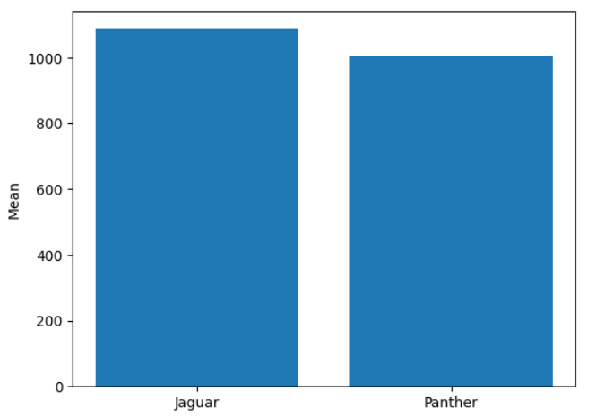**Mean -** Panther is closer to the target value of 1k ohms (Ω) since it has a mean value of **1005.33Ω,** while Jaguar's mean is farther with a value of **1087.8Ω.**

*Figure 6.A. Mean of Jaguar and Panther*

1. 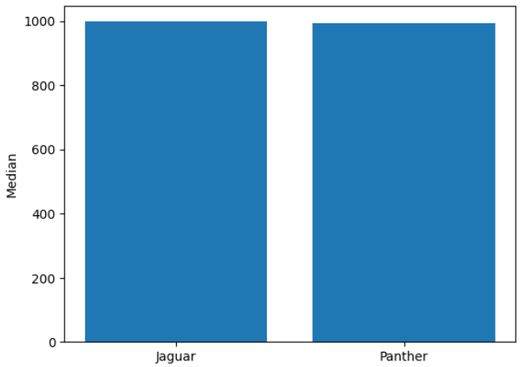**Median -** Jaguar's median value of **998Ω** is closer to the target rating of 1kΩ, while Panther's median value of **994.5Ω** is farther away. This means that Jaguar is more *accurate* than Panther

*Figure 6.B. Median of Jaguar and Panther*

1. 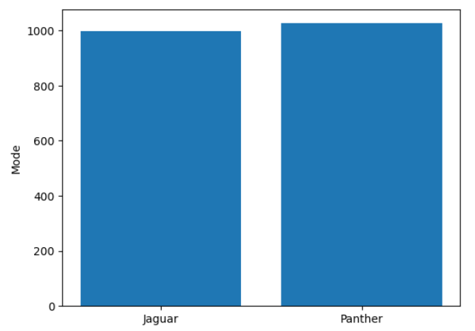**Mode -** Jaguar *frequently* produces resistors with a rating of **997Ω** which is closer to the target value than the most *frequent* resistors with ratings of **1026Ω** that Panther produces.

*Figure 6.C. Mode of Jaguar and Panther*

1. 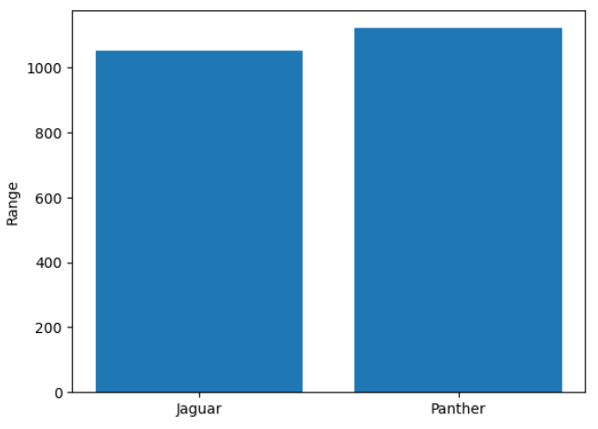**Range -** Panther has a range of **1120Ω** while Jaguar has a range of **1050Ω,** which may indicate Panther's higher variability in production.

*Figure 6.D. Range of Jaguar and Panther*

1. 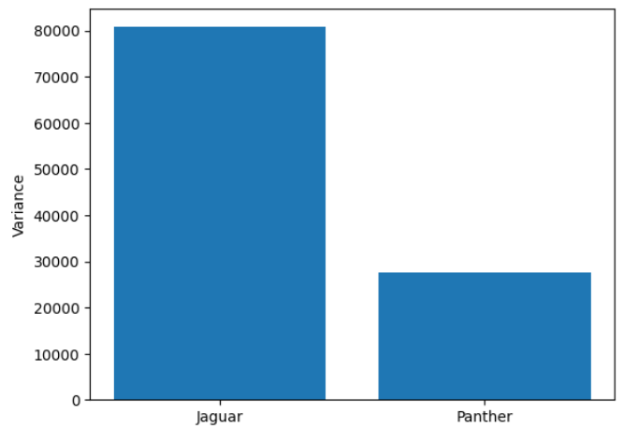**Variance -** Jaguar's variance of **80,749.82** is significantly higher than that of Panther's which has a value of **27,642.85**. This suggests that Panther produces resistors with great consistency in reaching the target rating compared to Jaguar.

*Figure 6.E. Variance of Jaguar and Panther*

1. 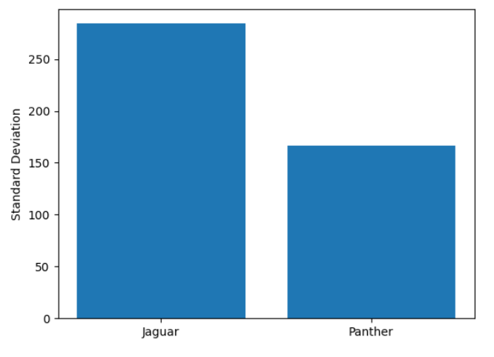**Standard Deviation -** Jaguar's has a standard deviation of **284.17,** indicating higher variability in its resistor's resistance ratings than of Panther's which has a standard deviation of **166.26.**

*Figure 6.F. Standard Deviation of Jaguar and Panther*

1. 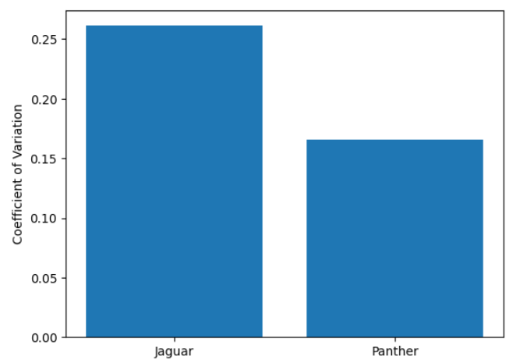**Coefficient of Variance/Variation -** Jaguar has a coefficient of variation of **0.26**, while Panther has a coefficient of variation of **0.17**. This suggests that Panther is more *consistent* in production.

*Figure 6.G. Coefficient of Variation of Jaguar and Panther*

1. **Summary**

* **Jaguar** has higher fluctuations in output, which could indicate operational inconsistencies or external factors influencing its performance. This fluctuation might be undesirable in production settings where consistency is essential.
* **Panther** shows much higher consistency in producing the target 1kΩ resistors, with low variability and fewer outliers.

1. **Recommendations**

* **Panther** has shown to be reliable in the production of 1kΩ resistors, but it is still recommended to find the cause of its outliers to lessen errors, though it is of a lower priority.
* **Jaguar's** consistency and accuracy in production are sub-standard, which might indicate some issues with the machine itself. As such, it is highly recommended that Jaguar is checked for maintenance and/or recalibrated post-haste as to lessen any production issues it may cause.

1. **Conclusion**

In conclusion, Panther is consistent in producing 1kΩ, with minimal variance and fewer outliers. However, due to said outliers, it is still recommended that it is checked or recalibrated to further improve its performance, although this is a lower priority. Jaguar, on the other hand, shows a lot of variances in its output, making it unreliable for consistent production of 1k Ω resistors. It is of utmost priority that Jaguar is checked for maintenance and possibly recalibrating it, to improve its reliability and avoid further issues.